Video content and links for knowledge centre.

# This video from DEHH shows the ease of installation when utilising their DEHNclip® for rebar installations.

<https://youtu.be/2a4RnZiEcMk>

This video from DEHN gives a brief explanation of how to install an SPD in a distribution board. Remember this should only be done by a suitably qualified electrician.

<https://youtu.be/1Cmiz91uq2I>

This video again from DEHN shows the installation of a Type 3 Surge Protection Device, the simplest form of SPD. Remember this should only be done by a suitably qualified electrician.

<https://youtu.be/sdke3jYLzMc?list=PLUJ5-rGtZwb6vedMjaht4QgLfavfDHWc6>

A bit more unusual and complex this one, this Dehn video shows the installation of surge protection in an electrocoustic system using DEHNvario.

<https://youtu.be/hLTOaXUCEPQ?list=PLUJ5-rGtZwb4Xcds2kf-WR4zWg4Gt7kb3>

For the boffins or just plain inquisitive amongst you here’s a keynote speakers’ presentation regarding lightning protection within aviation and the use of simulation and calculations. This is very interesting stuff, if not a little deep!

[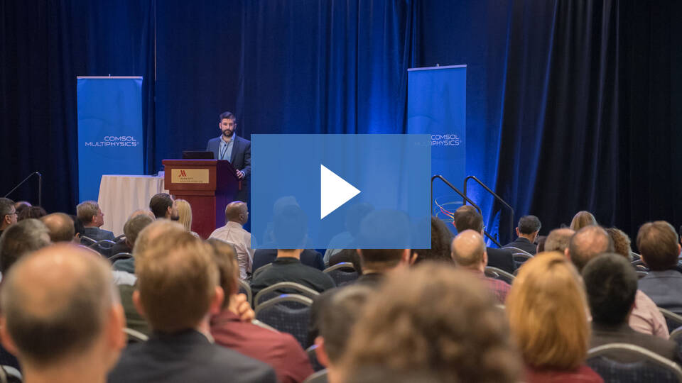](https://www.comsol.com/video/evaluating-lightning-protection-designs-with-simulation?wvideo=n8o9a5ibr7)

[Keynote: Evaluating Lightning Protection Designs with Simulation](https://www.comsol.com/video/evaluating-lightning-protection-designs-with-simulation?wvideo=n8o9a5ibr7)

This is a very simple, less than two-minute explanation of how Lightning works, fun to watch.

<https://youtu.be/Cz_uYBx1G5s>

This video captures some of the stranger forms of lightning and explains some of the scalene behind them. An easy 4-and-a-half-minute watch.

<https://youtu.be/KO3H285CFRo>

Fun stuff, If you just can’t get enough of lightning strikes or the last video got your interest going for more here’s another great selection.

<https://youtu.be/TaPgSWdcYtY>

Now you really want to be avoiding getting struck by lightning and we provide some safety advice elsewhere on the site, but hers what actually happens if you get struck. It’s probably best you watch it before it happens.

<https://www.youtube.com/watch?v=T3BT-cnHjik>

Here’s some advice on how to survive a lightning strike. Simple but may just be effective.

<https://www.youtube.com/watch?v=eNxDgd3D_bU>

Here’s a link to the live lightning strike map for Europe, so the little yellow and red dots are strikes and you can look at this in real-time or delayed as well as with a counting grid or without. Gives you a real sense of quite how many strikes occur every single day!

<https://www.lightningmaps.org/#m=oss;t=3;s=0;o=0;b=;ts=0;ps://www.youtube.com/watch?v=LAATySw3Zmk>